**Run the SpringBoot project**

1. mvn clean install -U
2. mvn spring-boot:run -X

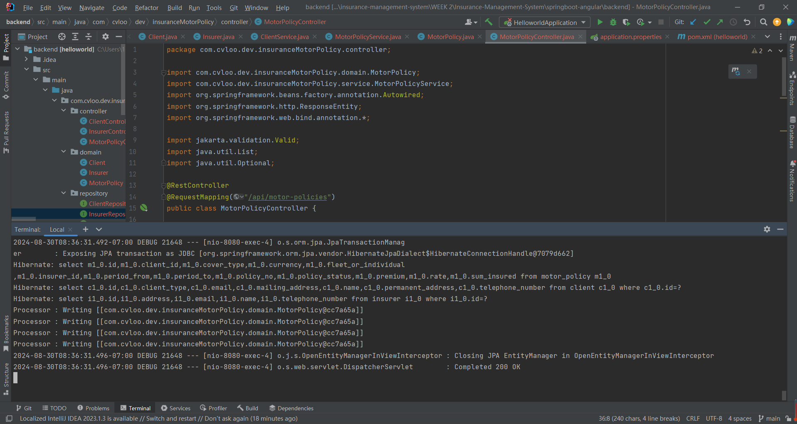

**Testing APIs in ‘ClientController’**

1. Create Client

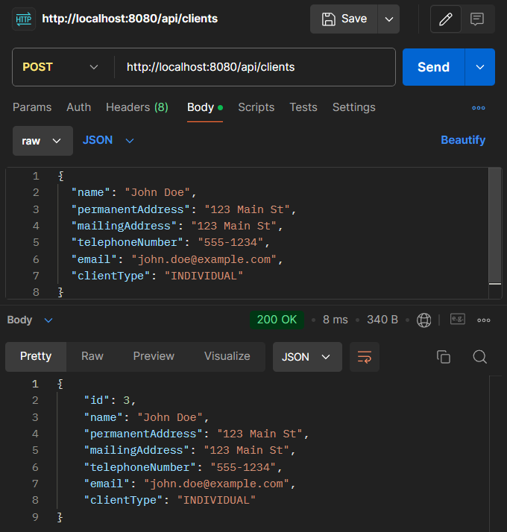

1. Get All Clients

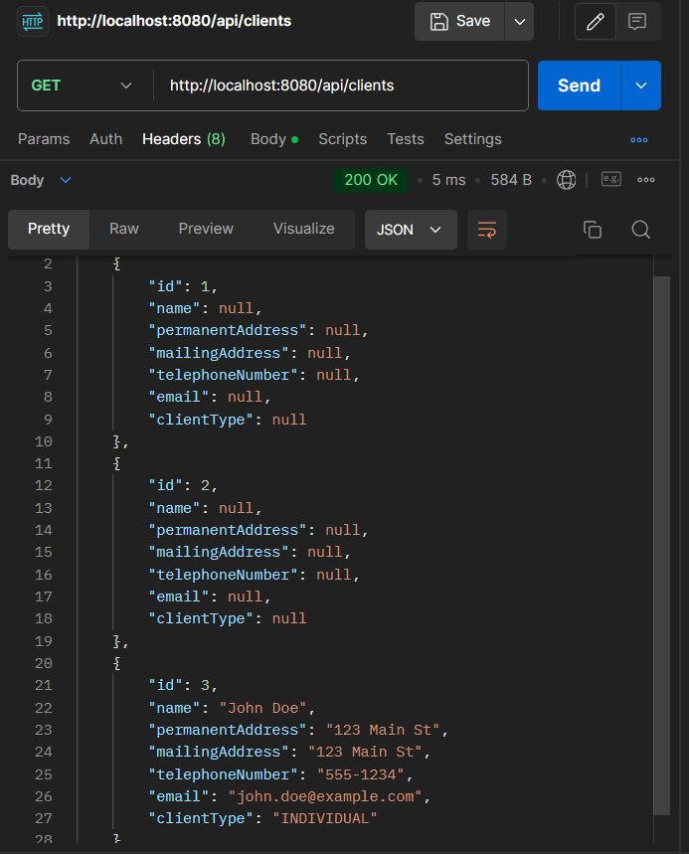

1. Get Client by ID

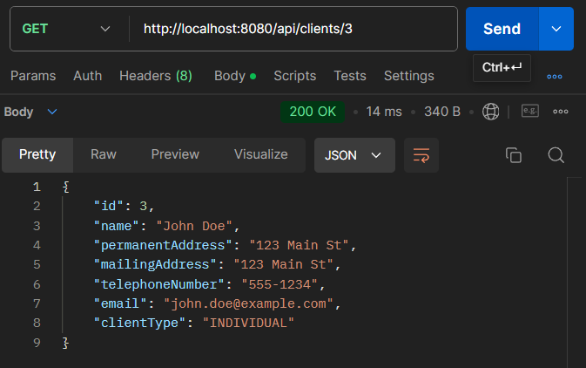

1. Update Client

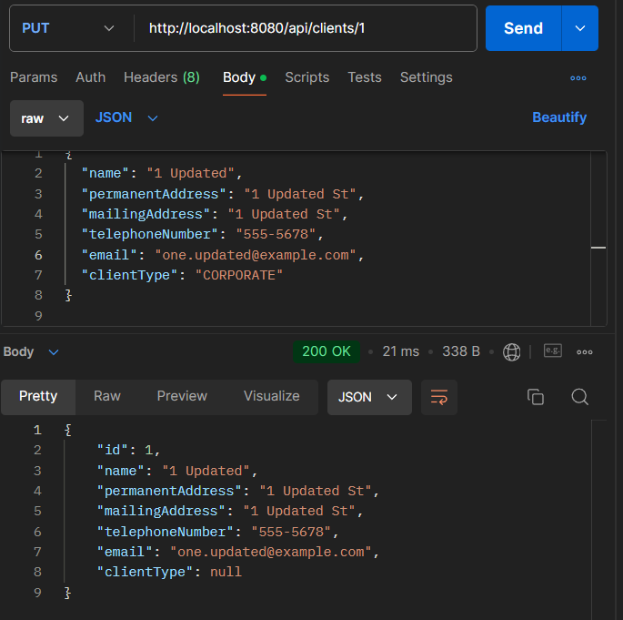

1. Delete Client

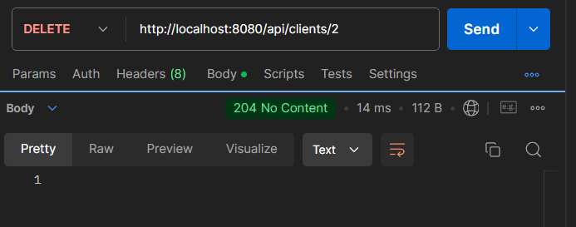

When we have a look again:

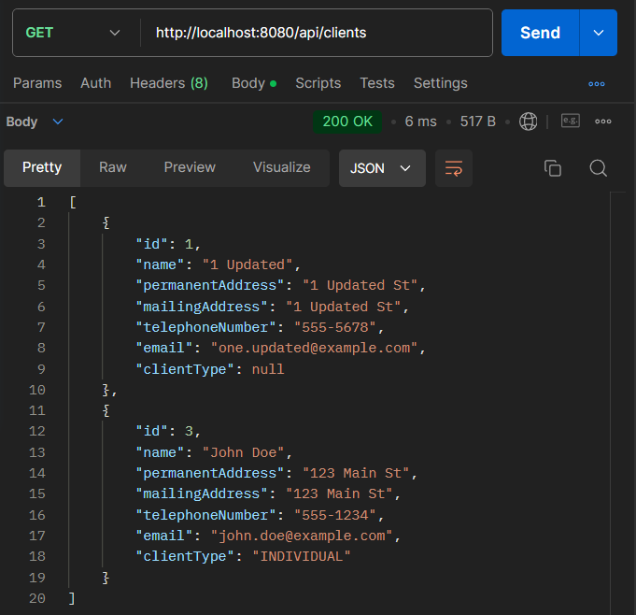

**Testing APIs in ‘InsurerController’**

1. Create Insurer

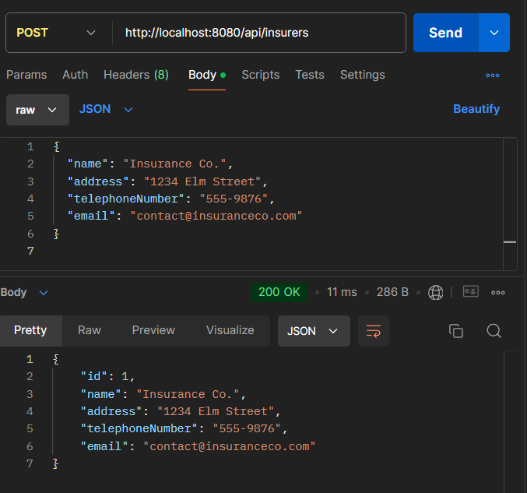

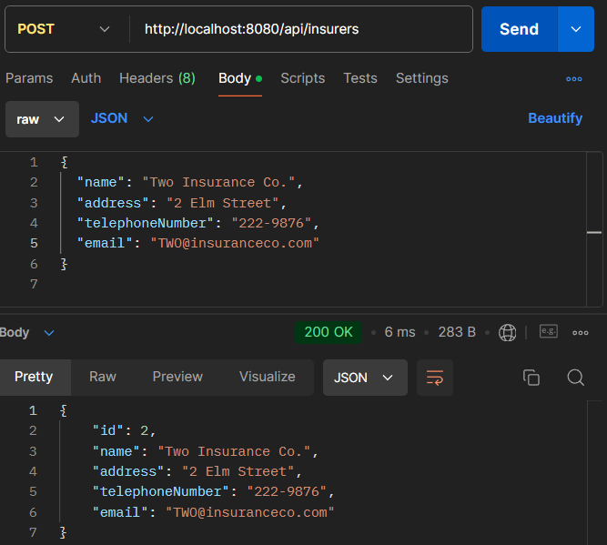

1. Get All Insurer

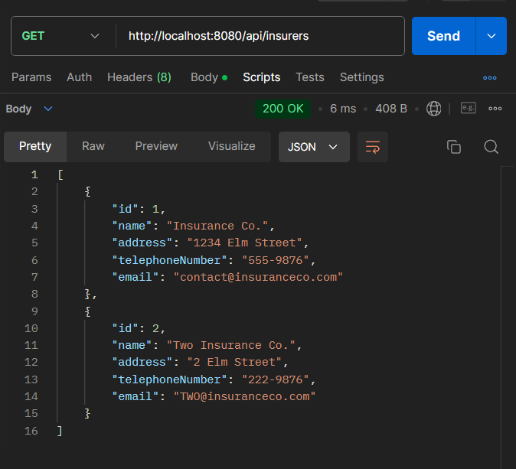

1. Get Insurer by ID

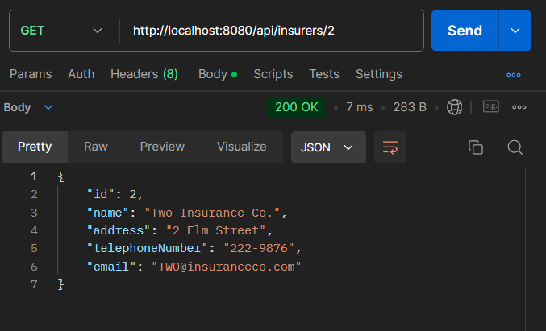

1. Update Insurer

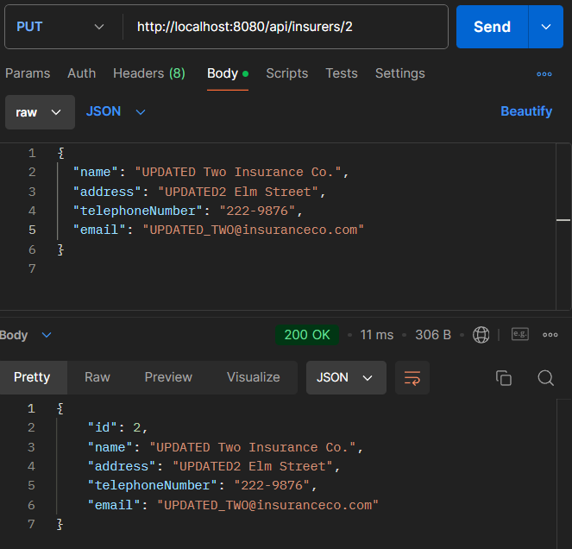

1. Delete Insurer

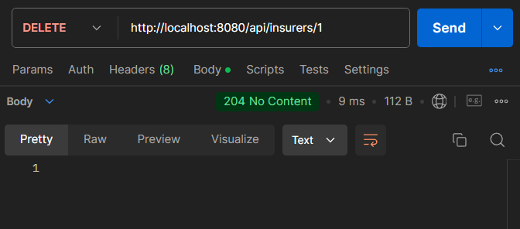

After deleting:

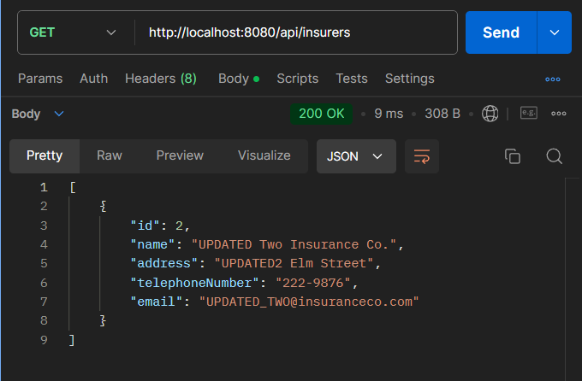

**Testing APIs in ‘MotorPolicyController’**

1. Create Motor Policy

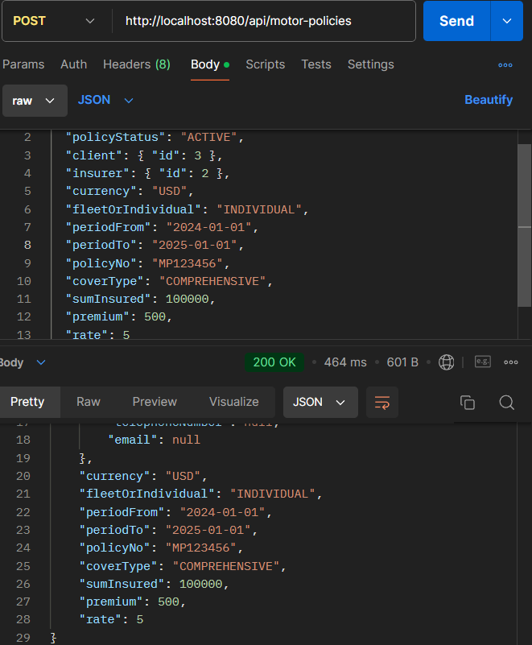

{

"id": 1,

"policyStatus": "ACTIVE",

"client": {

"id": 3,

"name": null,

"permanentAddress": null,

"mailingAddress": null,

"telephoneNumber": null,

"email": null,

"clientType": null

},

"insurer": {

"id": 2,

"name": null,

"address": null,

"telephoneNumber": null,

"email": null

},

"currency": "USD",

"fleetOrIndividual": "INDIVIDUAL",

"periodFrom": "2024-01-01",

"periodTo": "2025-01-01",

"policyNo": "MP123456",

"coverType": "COMPREHENSIVE",

"sumInsured": 100000,

"premium": 500,

"rate": 5

}

There would be an error if ‘periodTo’ is changed to what’s before ‘periodFrom’:

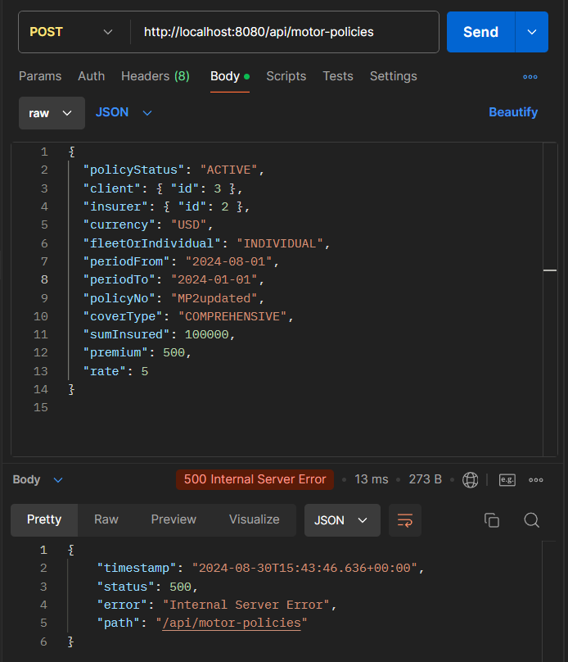

I added 2 policies in total so that after deleting we can still have one left.

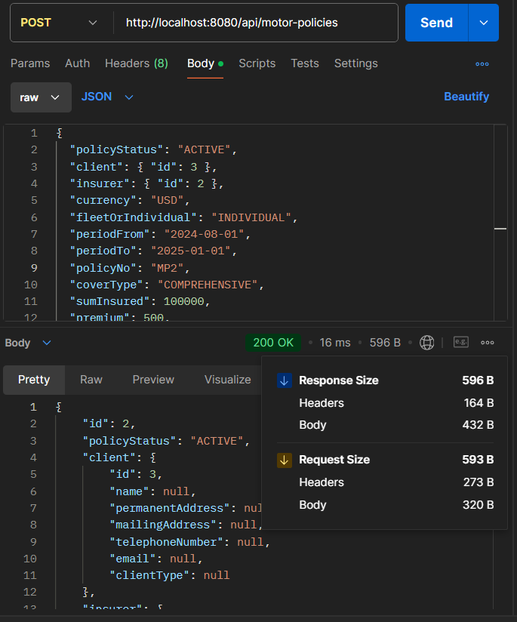

If some of the ‘@notnull’ values (/src/main/java/…/domain/MotorPolicy.java) were set to ‘null’:

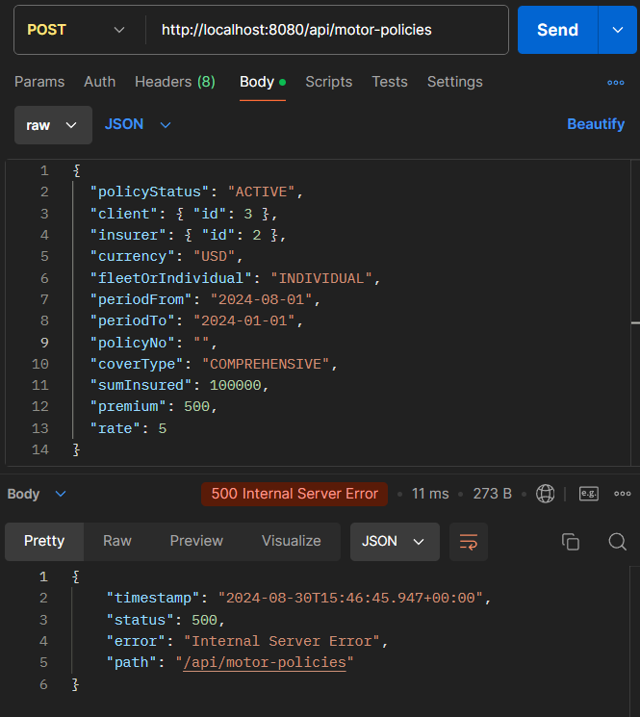

1. Get All Motor Policy

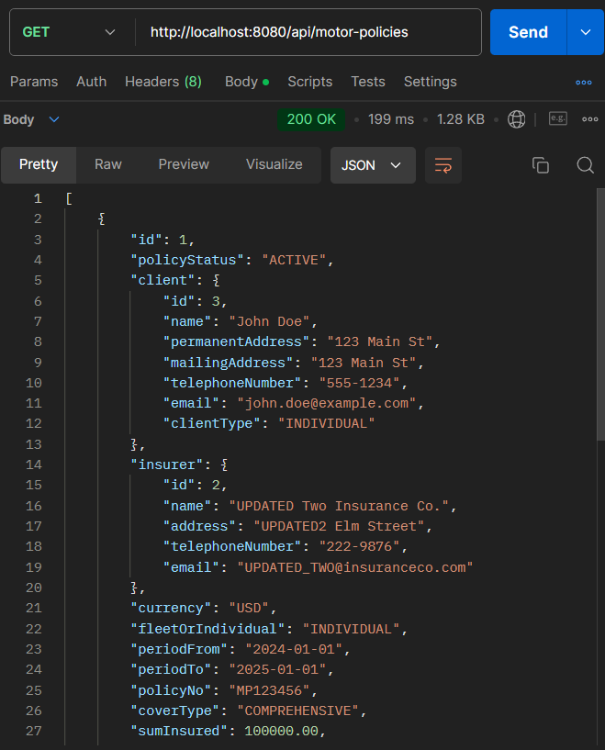

[

{

"id": 1,

"policyStatus": "ACTIVE",

"client": {

"id": 3,

"name": "John Doe",

"permanentAddress": "123 Main St",

"mailingAddress": "123 Main St",

"telephoneNumber": "555-1234",

"email": "john.doe@example.com",

"clientType": "INDIVIDUAL"

},

"insurer": {

"id": 2,

"name": "UPDATED Two Insurance Co.",

"address": "UPDATED2 Elm Street",

"telephoneNumber": "222-9876",

"email": "UPDATED_TWO@insuranceco.com"

},

"currency": "USD",

"fleetOrIndividual": "INDIVIDUAL",

"periodFrom": "2024-01-01",

"periodTo": "2025-01-01",

"policyNo": "MP123456",

"coverType": "COMPREHENSIVE",

"sumInsured": 100000.00,

"premium": 500.00,

"rate": 5.00

},

{

"id": 2,

"policyStatus": "ACTIVE",

"client": {

"id": 3,

"name": "John Doe",

"permanentAddress": "123 Main St",

"mailingAddress": "123 Main St",

"telephoneNumber": "555-1234",

"email": "john.doe@example.com",

"clientType": "INDIVIDUAL"

},

"insurer": {

"id": 2,

"name": "UPDATED Two Insurance Co.",

"address": "UPDATED2 Elm Street",

"telephoneNumber": "222-9876",

"email": "UPDATED_TWO@insuranceco.com"

},

"currency": "USD",

"fleetOrIndividual": "INDIVIDUAL",

"periodFrom": "2024-08-01",

"periodTo": "2025-01-01",

"policyNo": "MP2",

"coverType": "COMPREHENSIVE",

"sumInsured": 100000.00,

"premium": 500.00,

"rate": 5.00

}

]

1. Get Motor Policy by ID

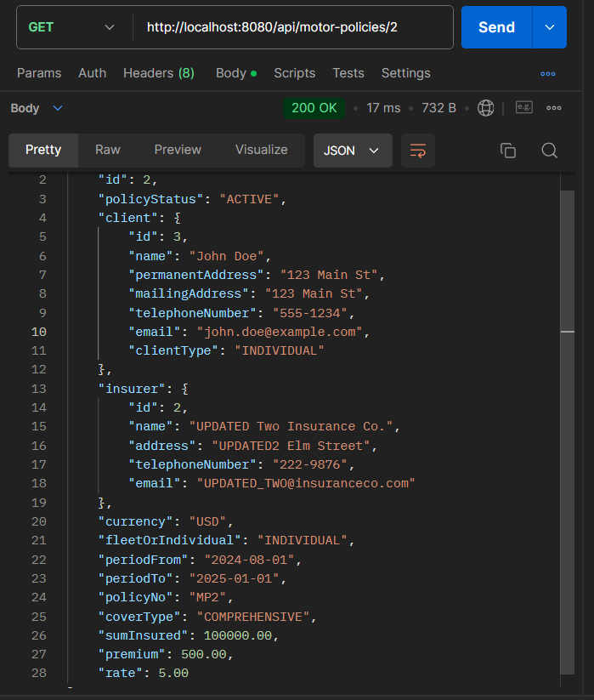

1. Update Motor Policy

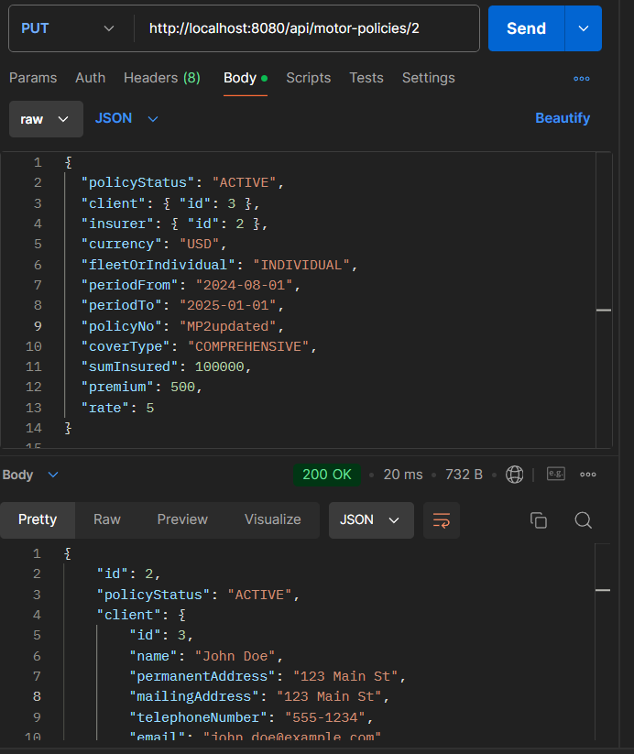

1. Delete Motor Policy

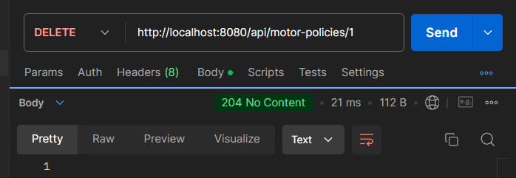

After deleting:

